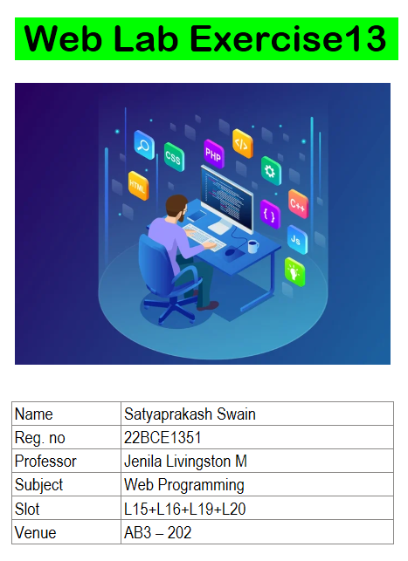

**1. (i) Create a React component that displays "Hello, React!" inside an <h1> tag without**

**JSX.**

import React from 'react';

function HelloReact() {

*return* React.createElement('h1', null, 'Hello, React!');

}

export default function App() {

*return* (

<div>

{React.createElement(HelloReact)}

</div>

);

}

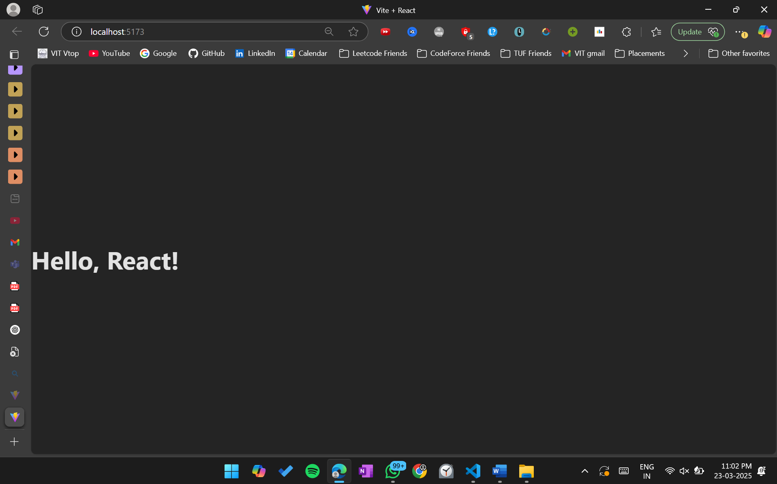

**(ii) Modify the above code and solve using React JSX**

import React from 'react';

function HelloReact() {

*return* <h1>Hello, React!</h1>;

}

export default function App() {

*return* (

<div>

<HelloReact />

</div>

);

}

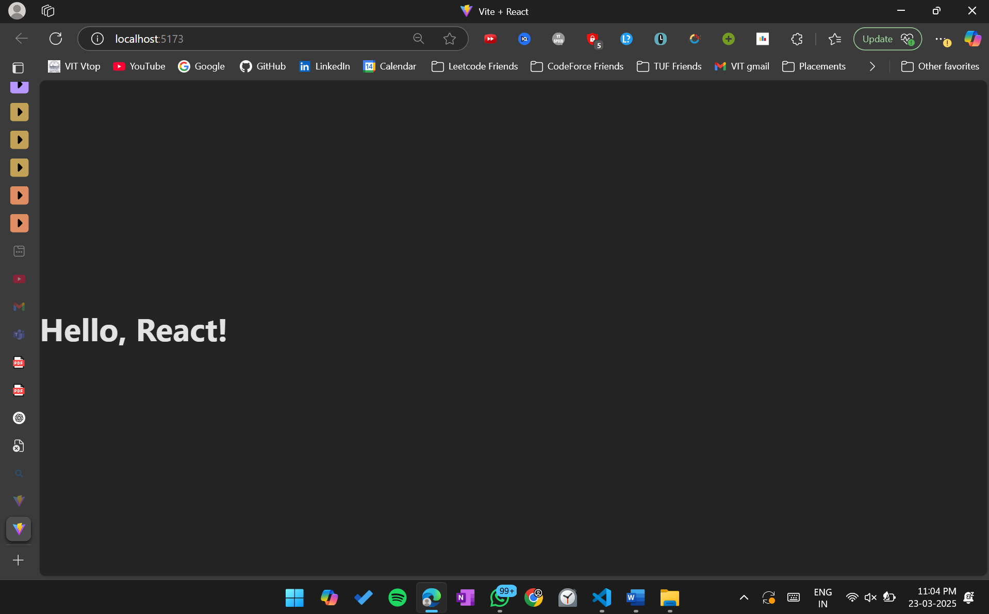

**(iii) Modify the above component to display a message stored in a variable.**

import React from 'react';

function HelloReact() {

*const* message = 'Hello, React!';

*return* React.createElement('h1', null, message);

}

export default function App() {

*return* (

<div>

{React.createElement(HelloReact)}

</div>

);

}

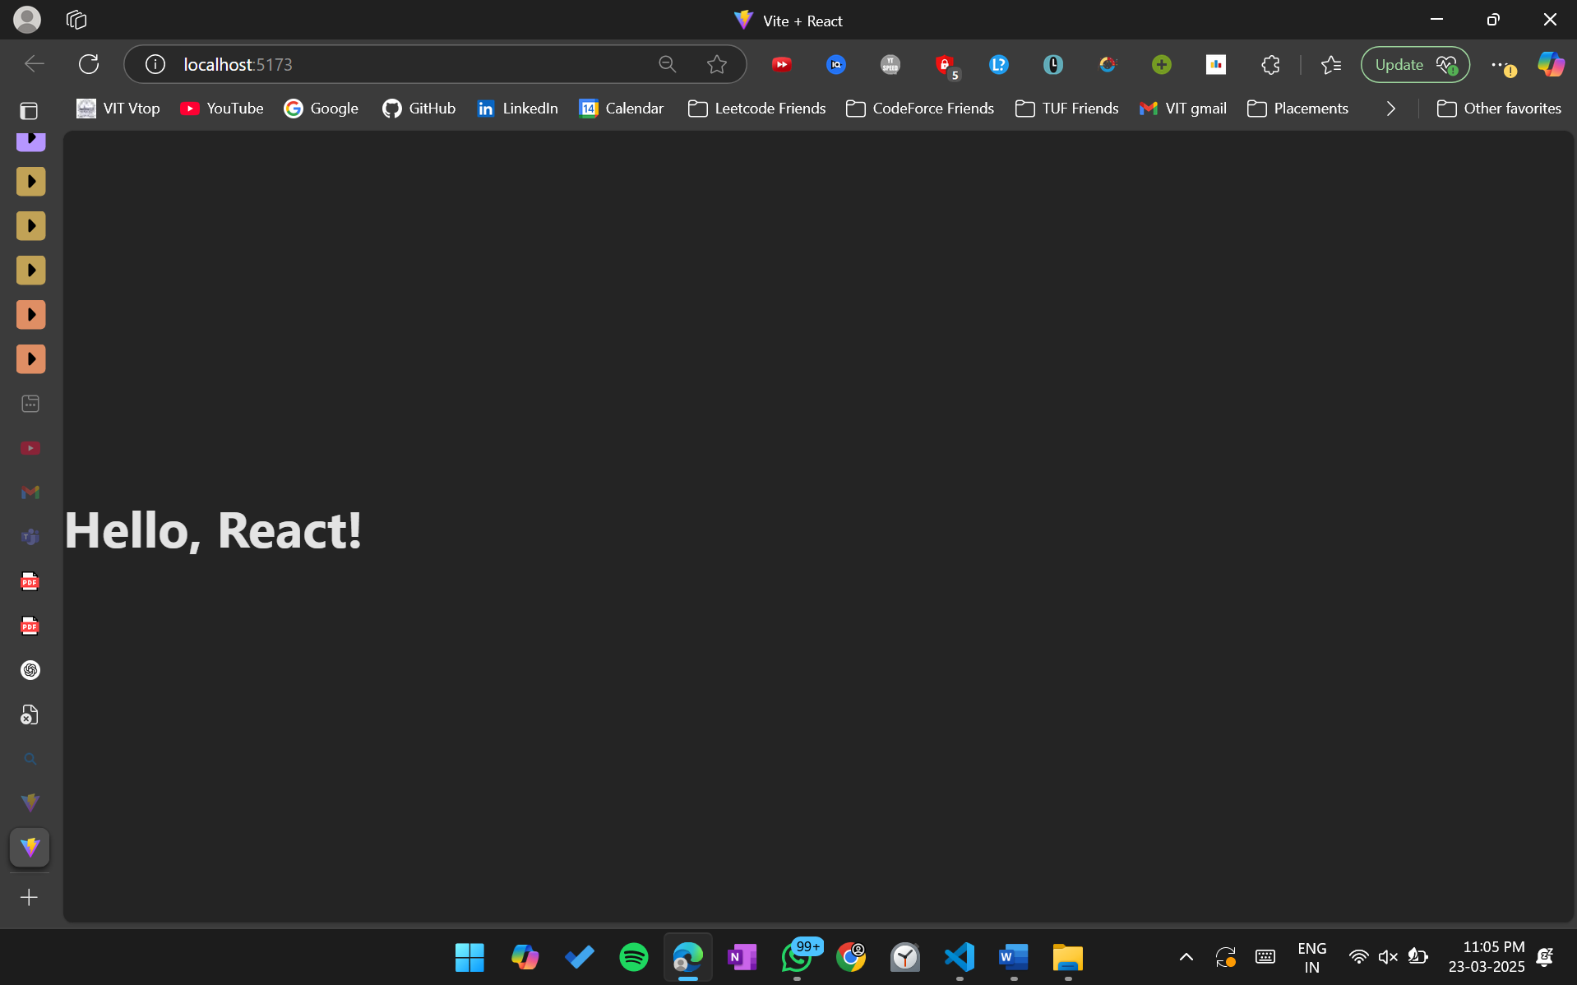

**2. Create a component that renders a list of three fruits dynamically.**

import React from 'react';

function FruitList() {

*const* fruits = ['Apple', 'Banana', 'Cherry'];

*return* (

<ul>

{fruits.map((fruit, index) => (

<li key={index}>{fruit}</li>

))}

</ul>

);

}

export default function App() {

*return* (

<div>

<h1>Fruit List</h1>

<FruitList />

</div>

);

}

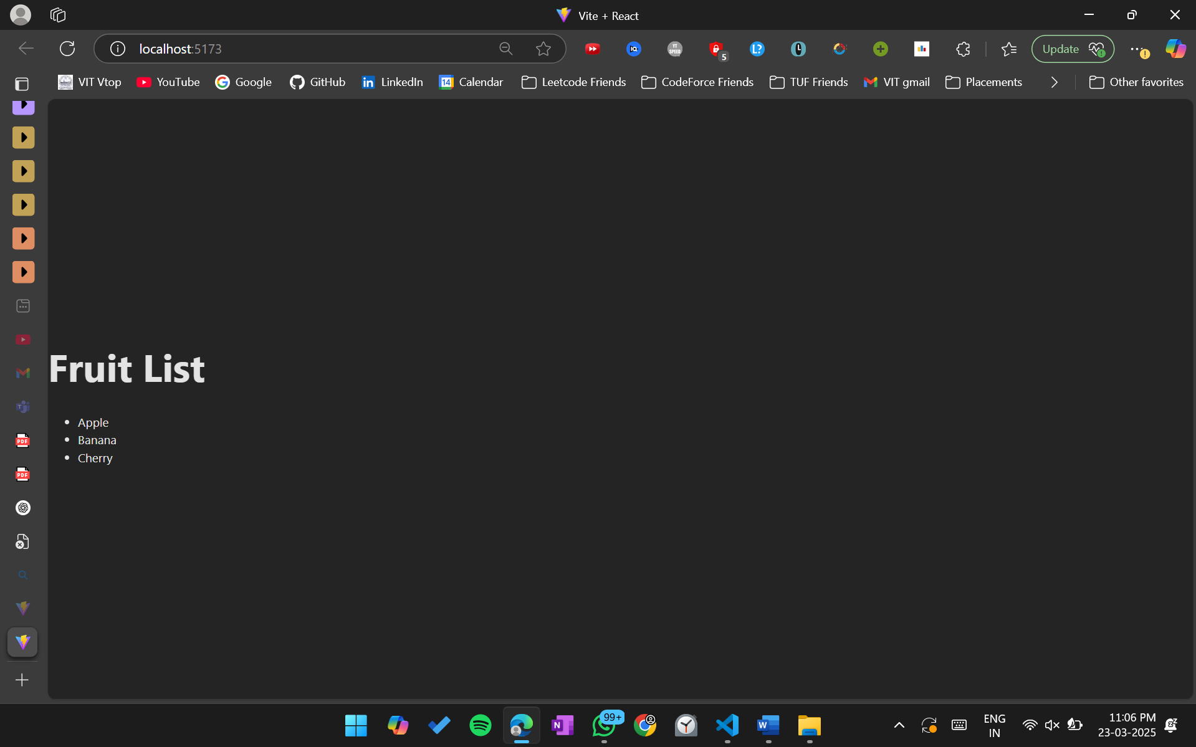

**3. Create a component that displays a styled message using inline CSS in JSX.**

import React from 'react';

function StyledMessage() {

*const* styles = {

color: 'blue',

fontSize: '24px',

fontWeight: 'bold',

textAlign: 'center',

};

*return* <p style={styles}>This is a styled message!</p>;

}

export default function App() {

*return* (

<div>

<h1>Styled Message</h1>

<StyledMessage />

</div>

);

}

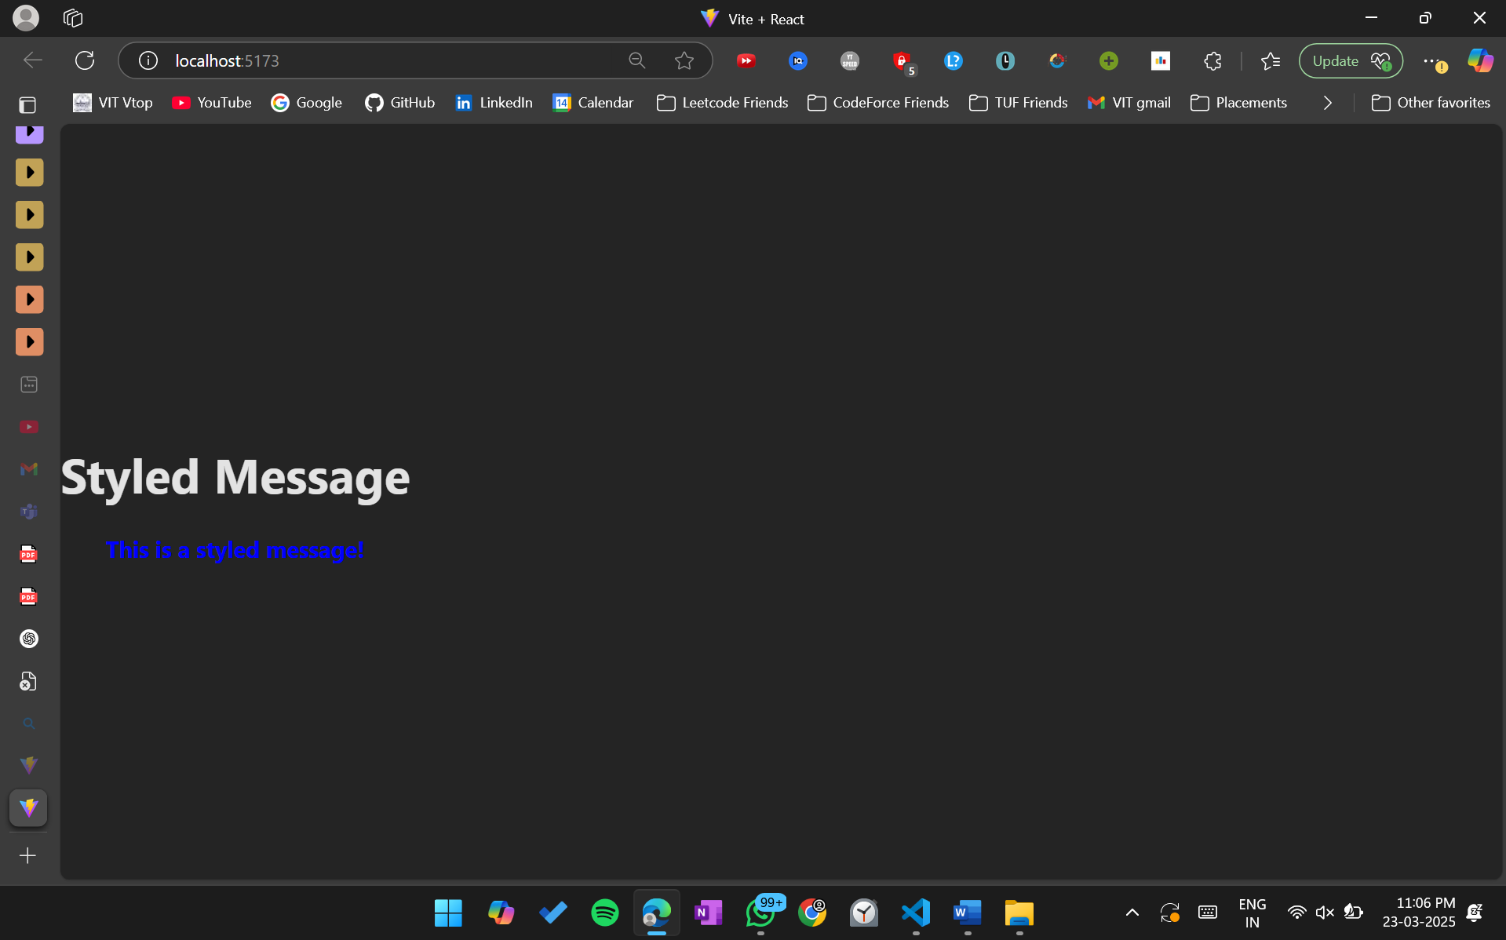

**4. Create a component that displays the sum of squares of two numbers inside a <p> tag.**

import React from 'react';

function SumOfSquares() {

*const* num1 = 5;

*const* num2 = 7;

*const* sumOfSquares = num1 * num1 + num2 * num2;

*return* <p>The sum of squares of {num1} and {num2} is {sumOfSquares}.</p>;

}

export default function App() {

*return* (

<div>

<h1>Sum of Squares</h1>

<SumOfSquares />

</div>

);

}

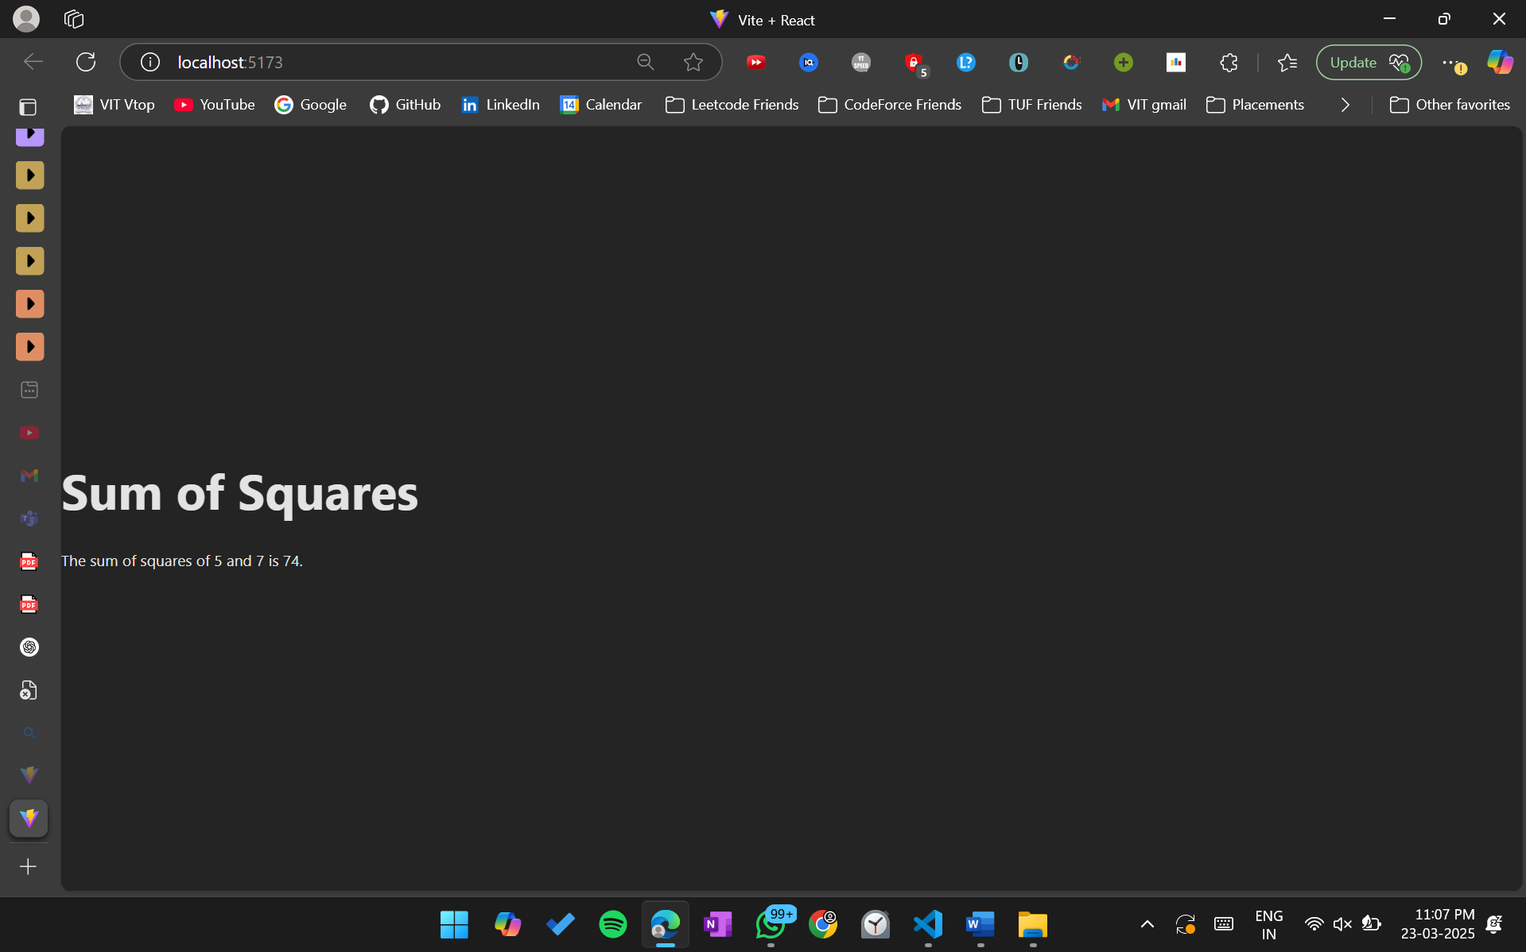

**5. Create a component that displays "Good Morning" if isMorning is true, otherwise display "Good Evening."**

import React from 'react';

function Greeting() {

*const* isMorning = true;

*return* <p>{isMorning ? 'Good Morning' : 'Good Evening'}</p>;

}

export default function App() {

*return* (

<div>

<h1>Greeting</h1>

<Greeting />

</div>

);

}

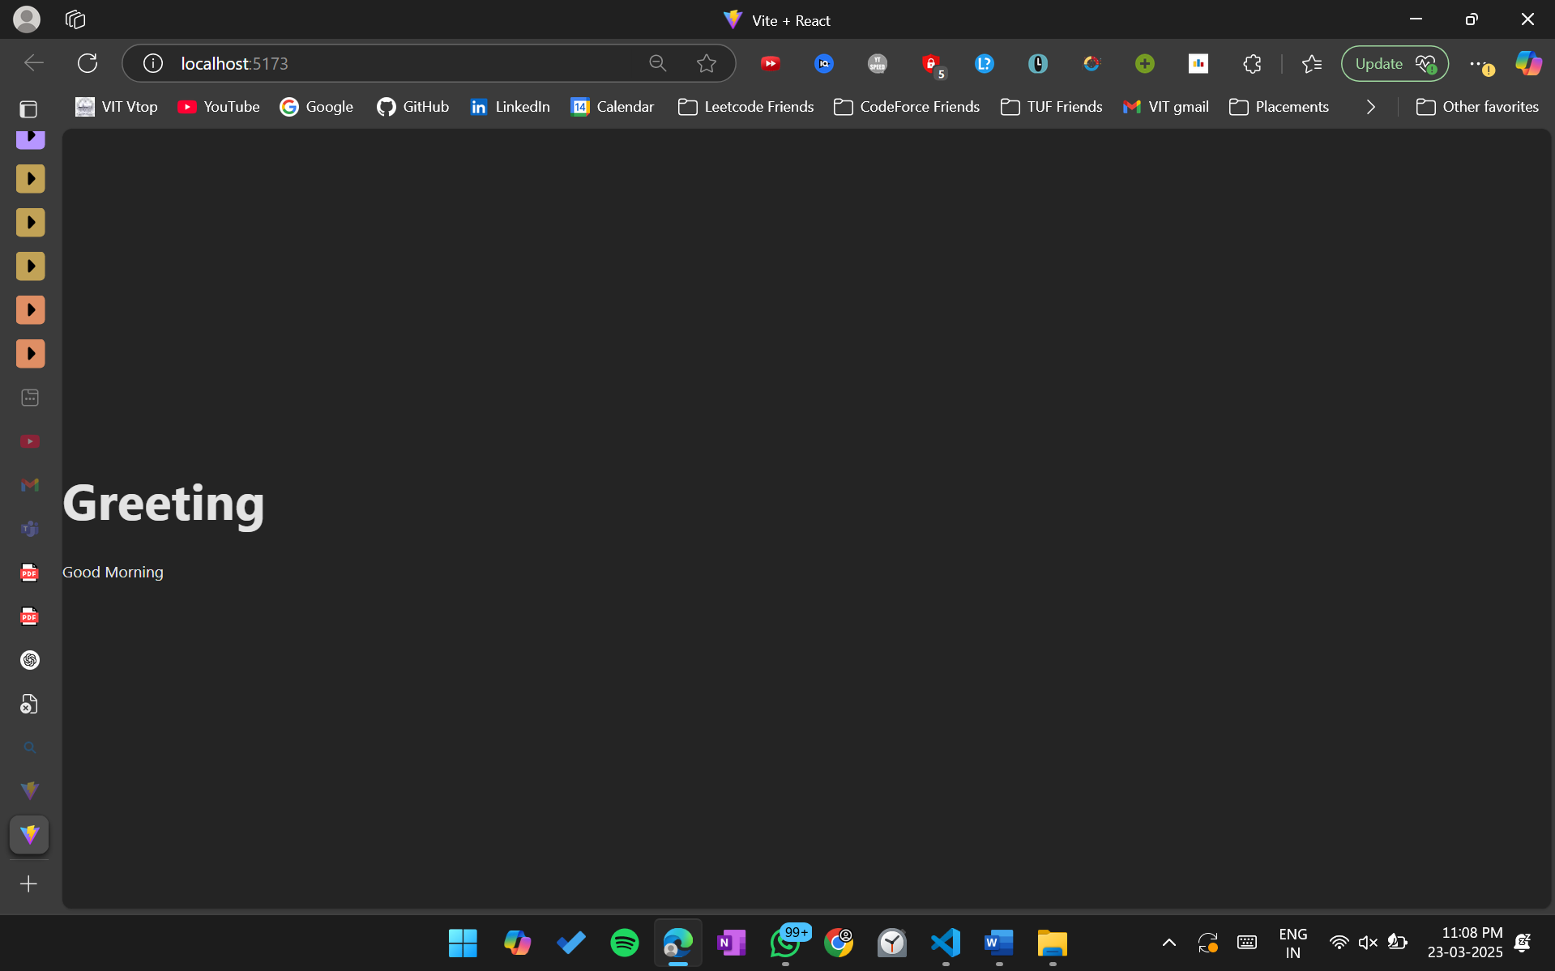

**6. Create a React component that displays the current day of the week dynamically using JavaScript's**

import React from 'react';

function CurrentDay() {

*const* daysOfWeek = ['Sunday', 'Monday', 'Tuesday', 'Wednesday', 'Thursday', 'Friday', 'Saturday'];

*const* today = new Date();

*const* currentDay = daysOfWeek[today.getDay()];

*return* <p>Today is {currentDay}.</p>;

}

export default function App() {

*return* (

<div>

<h1>Current Day</h1>

<CurrentDay />

</div>

);

}

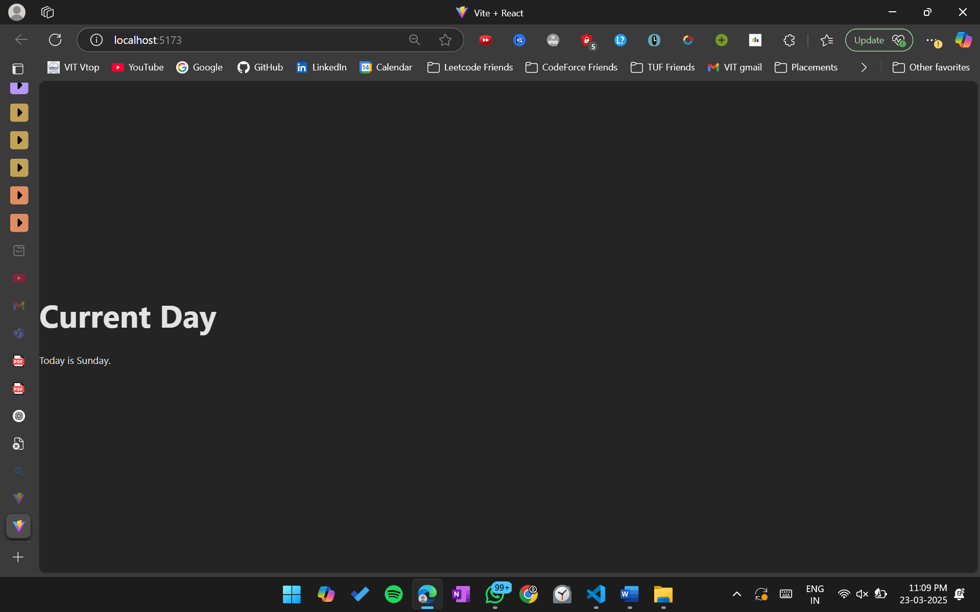

**7. Create a React component that checks whether a given number is prime and displays the result.**

import React from 'react';

function isPrime(num) {

if (num <= 1) *return* false;

for (*let* i = 2; i <= Math.sqrt(num); i++) {

if (num % i === 0) *return* false;

}

*return* true;

}

function PrimeChecker() {

*const* number = 29;

*const* result = isPrime(number) ? 'is a prime number' : 'is not a prime number';

*return* <p>The number {number} {result}.</p>;

}

export default function App() {

*return* (

<div>

<h1>Prime Checker</h1>

<PrimeChecker />

</div>

);

}

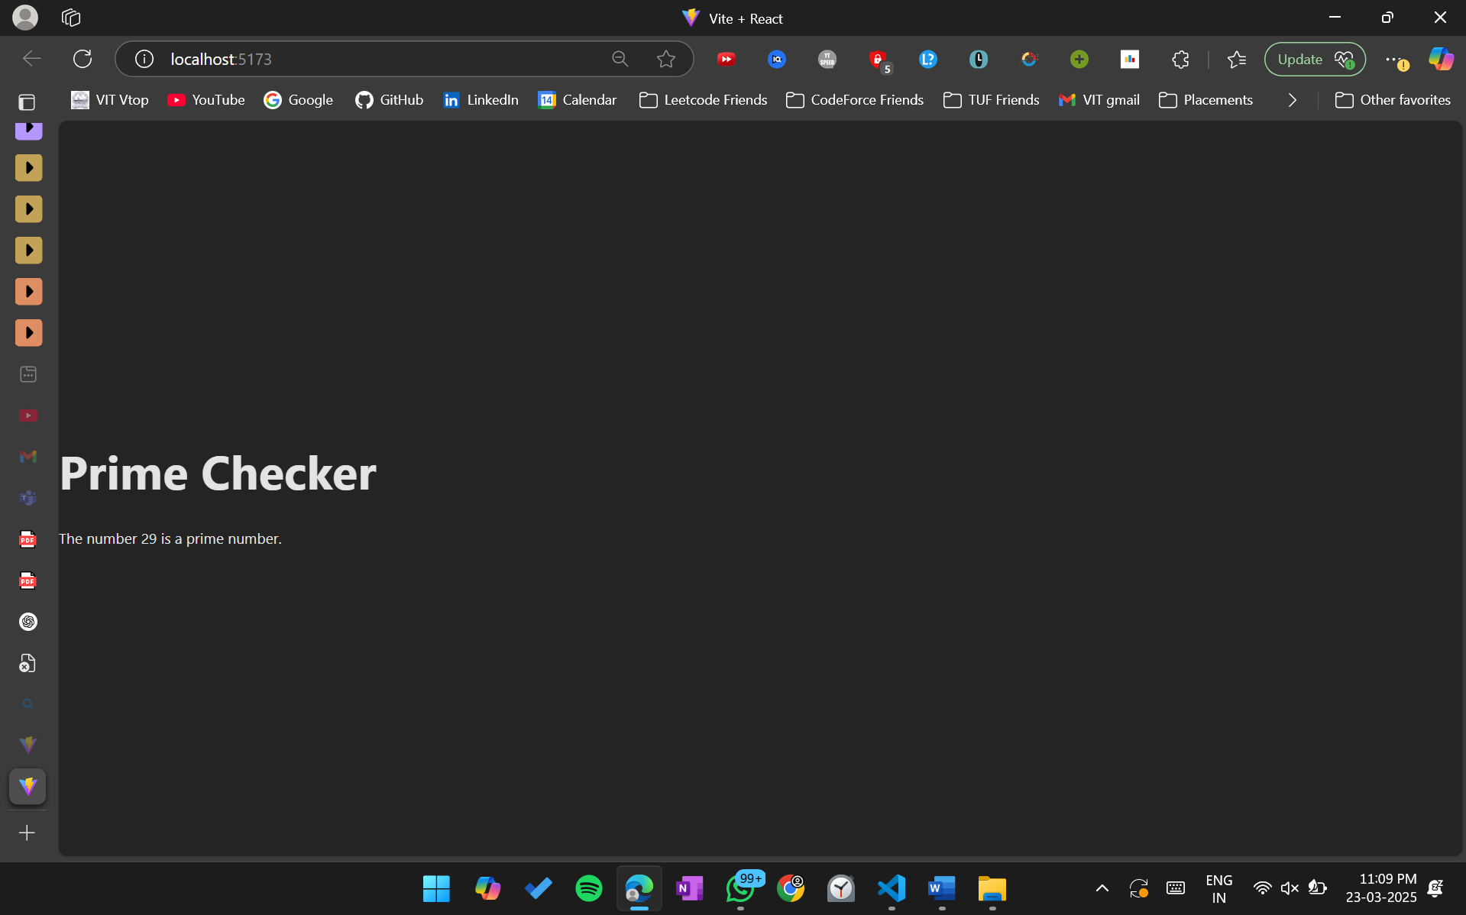

**8. Create a React class component called TemperatureConverter that allows the user to convert a temperature from Celsius to Fahrenheit and Fahrenheit to Celsius.**

import React, { Component } from 'react';

class TemperatureConverter *extends* Component {

constructor(props) {

super(props);

this.state = {

temperature: '',

scale: 'celsius',

};

}

handleCelsiusChange = (e) => {

this.setState({ temperature: e.target.value, scale: 'celsius' });

};

handleFahrenheitChange = (e) => {

this.setState({ temperature: e.target.value, scale: 'fahrenheit' });

};

render() {

*const* { temperature, scale } = this.state;

*const* celsius =

scale === 'fahrenheit' ? ((temperature - 32) * 5) / 9 : temperature;

*const* fahrenheit =

scale === 'celsius' ? (temperature * 9) / 5 + 32 : temperature;

*return* (

<div>

<h2>Temperature Converter</h2>

<div>

<label>

Celsius:

<input

type="number"

value={scale === 'celsius' ? temperature : celsius.toFixed(2)}

onChange={this.handleCelsiusChange}

/>

</label>

</div>

<div>

<label>

Fahrenheit:

<input

type="number"

value={scale === 'fahrenheit' ? temperature : fahrenheit.toFixed(2)}

onChange={this.handleFahrenheitChange}

/>

</label>

</div>

</div>

);

}

}

export default function App() {

*return* (

<div>

<h1>Temperature Converter</h1>

<TemperatureConverter />

</div>

);

}

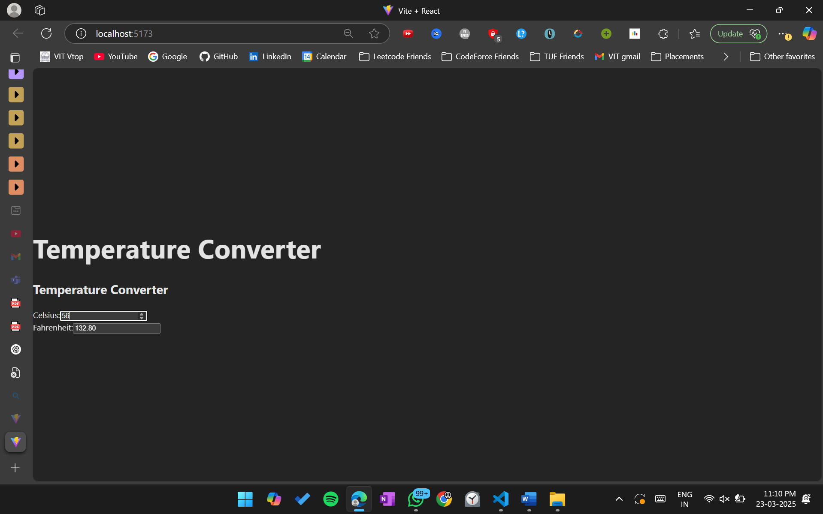

**9. Create a component that takes a string (e.g., "React") and displays its reverse ("tcaeR") inside a <p> tag and display whether the string is palindrome or not**

import React from 'react';

function StringManipulator() {

*const* str = 'madam';

*const* reversedStr = str.split('').reverse().join('');

*const* isPalindrome = str === reversedStr;

*return* (

<div>

<p>Original String: {str}</p>

<p>Reversed String: {reversedStr}</p>

<p>{isPalindrome ? 'The string is a palindrome.' : 'The string is not a palindrome.'}</p>

</div>

);

}

*// Export the App component*

export default function App() {

*return* (

<div>

<h1>String Manipulator</h1>

<StringManipulator />

</div>

);

}

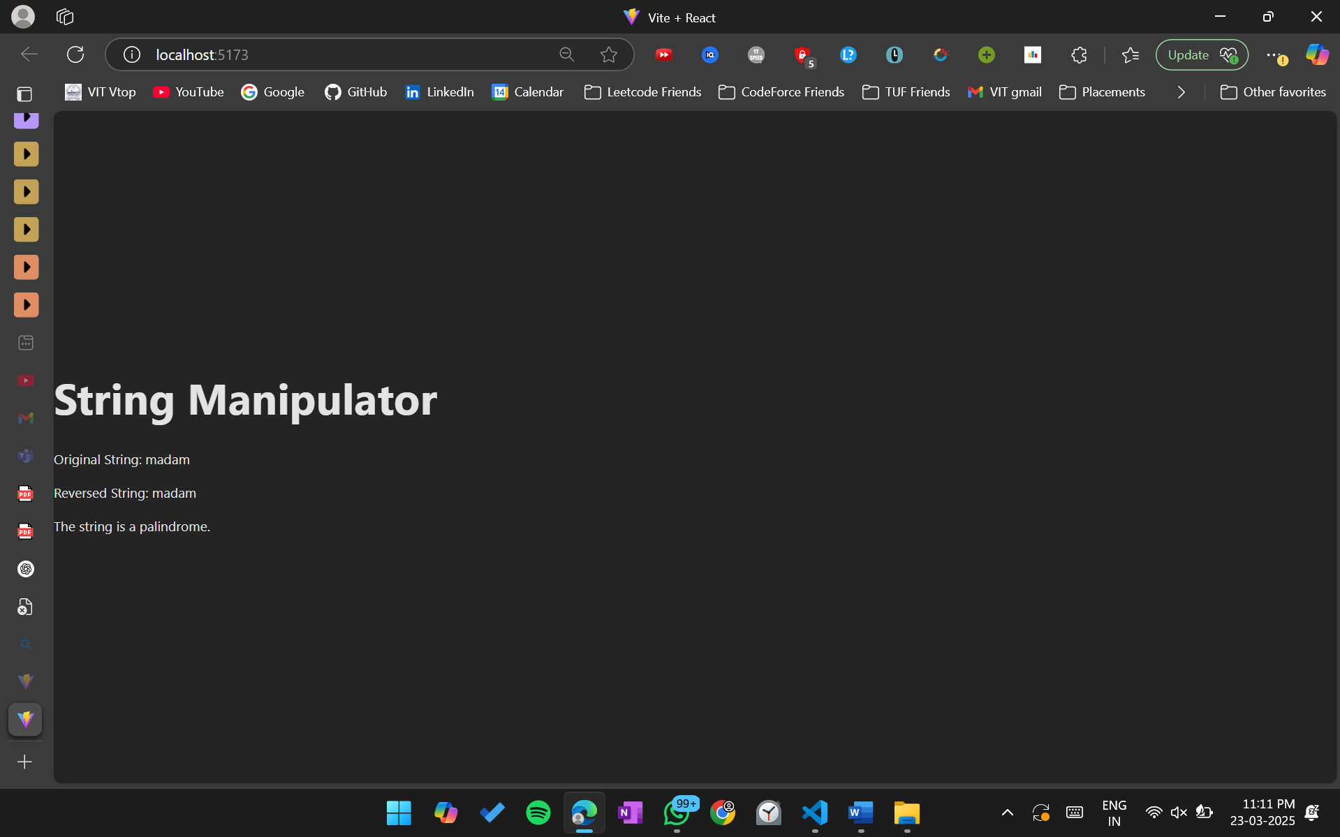

**10. Create a button that, when clicked, generates and displays a random number between 1 and 100.**

import React, { useState } from 'react';

function RandomNumberGenerator() {

*const* [randomNumber, setRandomNumber] = useState(null);

*const* handleClick = () => {

*const* num = Math.floor(Math.random() * 100) + 1;

setRandomNumber(num);

};

*return* (

<div>

<h2>Random Number Generator</h2>

<button onClick={handleClick}>Generate Random Number</button>

{randomNumber && <p>Generated Number: {randomNumber}</p>}

</div>

);

}

export default function App() {

*return* (

<div>

<h1>Random Number Generator</h1>

<RandomNumberGenerator />

</div>

);

}

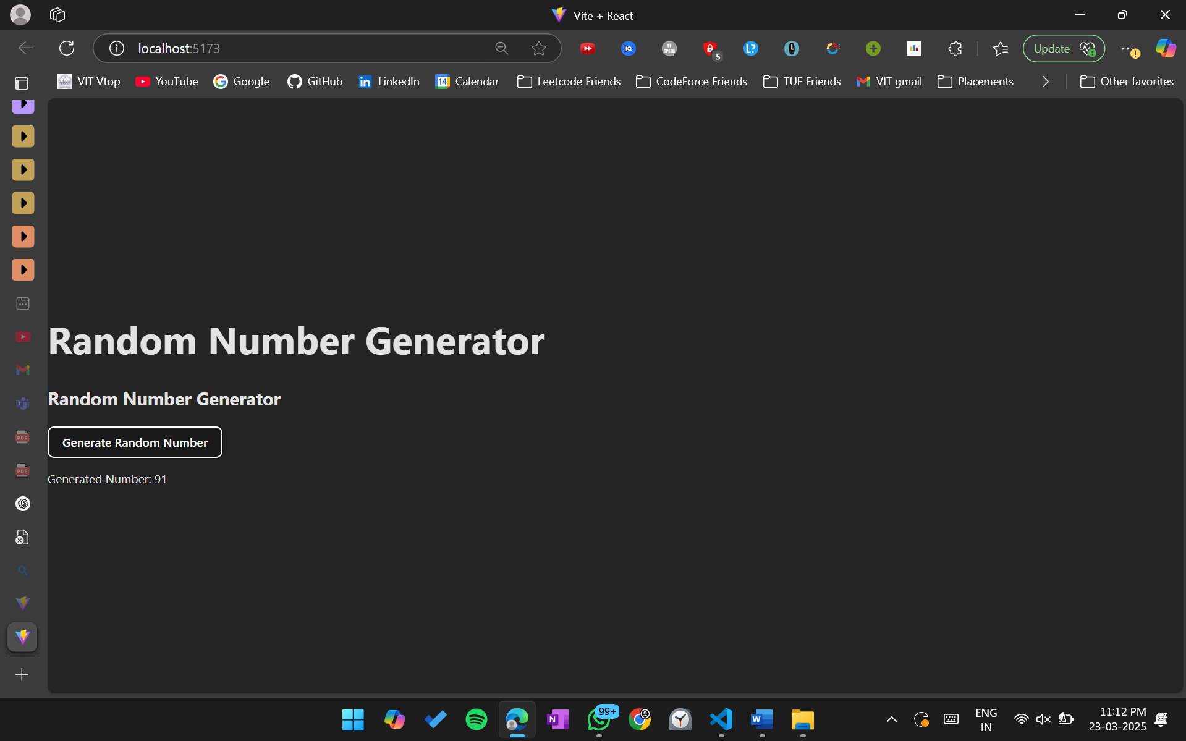

**11. Check If a Year is a Leap Year: Take a year (e.g., 2024) as a variable and display whether it is a leap year or not**

import React from 'react';

function LeapYearChecker() {

*const* year = 2024;

*const* isLeapYear =

(year % 4 === 0 && year % 100 !== 0) || year % 400 === 0;

*return* (

<p>

The year {year} is {isLeapYear ? 'a leap year.' : 'not a leap year.'}

</p>

);

}

export default function App() {

*return* (

<div>

<h1>Leap Year Checker</h1>

<LeapYearChecker />

</div>

);

}

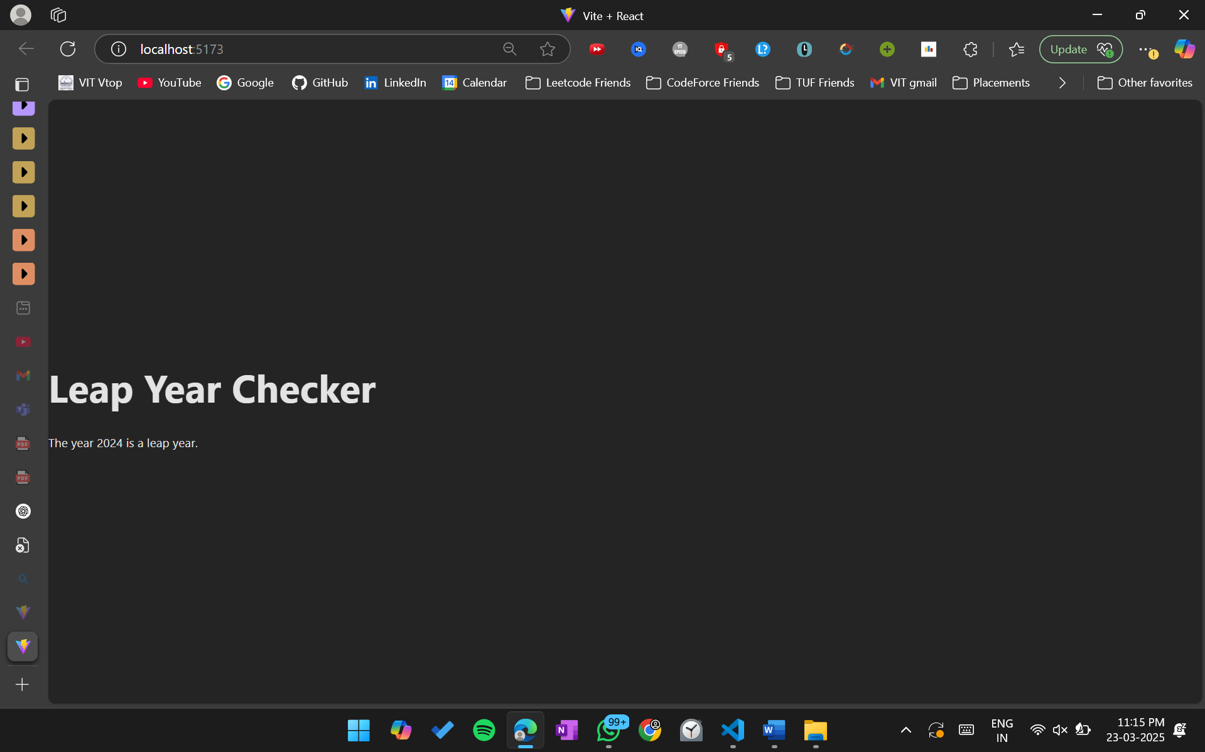

**12. Create a React class component named UserGreeting that takes two props: firstName and**

**lastName. Inside the render() method, display a greeting message with the full name of the user in the following format:**

**"Hello, [First Name] [Last Name]!"**

import React, { Component } from 'react';

class UserGreeting *extends* Component {

render() {

*const* { firstName, lastName } = this.props;

*return* <p>Hello, {firstName} {lastName}!</p>;

}

}

export default function App() {

*return* (

<div>

<h1>User Greeting</h1>

<UserGreeting firstName="Satyaprakash" lastName="swain" />

</div>

);

}

